My goal is to make a simple game based on Rock, Paper, Scissors. I want to code this only using JavaFX (no CSS or Javascript) to push my understanding of JavaFX. The program will have a starting state which most of the buttons and interface hidden, only showing the start button, background image, and images of hands. Then after pushing the start button, hide the start button and show most of the games interface in sort of a “playing state” screen. This state will show the buttons for “rock”, “paper”, and “scissors” and show the player and opponents life. The rock, paper, and scissors buttons will trigger methods that change images for the hands, determine opponent moves, change life totals depending on the outcome, and show a flashing label saying if the user won, lost, or tied. After a players life total is reduced to zero, it will show either a “you win” scene, or a “you lose” scene. Each scene will have a closing button that returns the state of the game back to its original starting state.

I think the hardest part of this program will be getting all of my images and objects set at correct positions and looking well. Normally when I write a GUI I tend to use CSS and/or Scene Builder to help me get everything in correct spots. Trying to position everything through hard coding I think will be the toughest part.

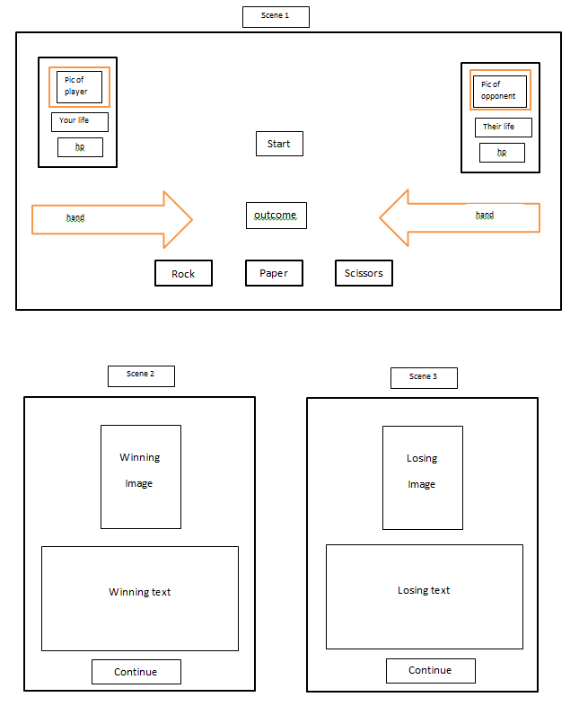

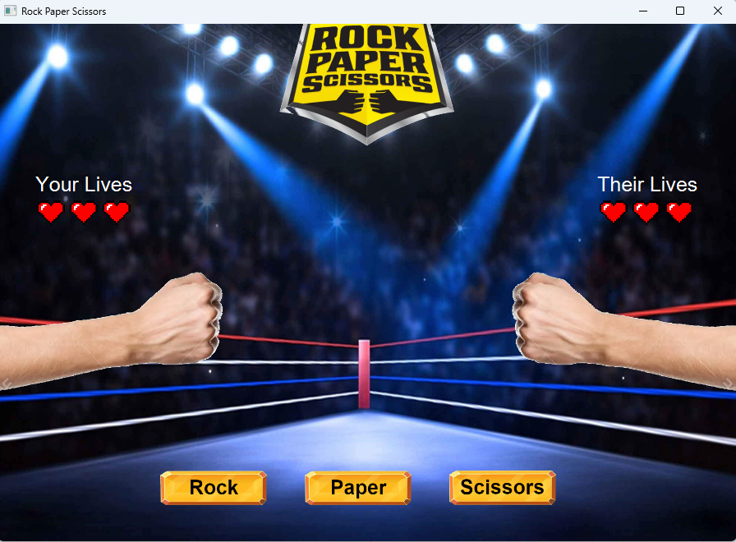

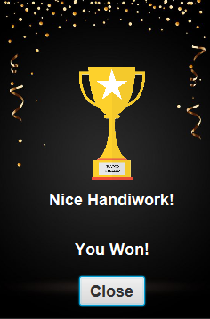 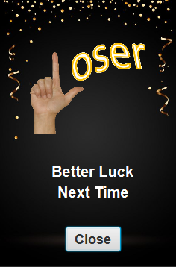

I had a great time with this project! It ended up being one of the larger projects I’ve done which felt very rewarding, but also came with a handful of new challenges. Figuring out how to structure this project was really interesting to me and it’s made me look into how other programs are set up. Trying to refractor and pull out methods to new classes was a bit challenging to figure out scope. I definitely wished I had planned out the structure a bit better at the beginning. There are a handful of methods and button actions I would have coded differently if I had.

The hardest part for me was getting the images correct. I’m no good with Photoshop although I learned a tiny bit through this. My hand images originally had the arms at slightly different heights/angles. When I attempted to overlay watches on top of them, they looked very off as I would update the hand images. This led to lots of cropping or extending canvases on each of the images to get things to line up correctly.

Attempting to make this whole project in just JavaFX and not use CSS was also pretty challenging. It made looking up bits of code online really hard and made my project really bulky. Hilariously, I was able to do the whole project without CSS except for setting the text on labels to white. I spent hours trying so many different attempts and StackOverflow bits of code on that one tiny issue and never found a solution in time. Its going to haunt me until I figure it out.

My final project ended up being pretty close to my original drawings. This project ended up being pretty large so I wanted to focus a lot of my time on getting structure and methods set up correctly. So I ran out of time on some features I wanted to add. I wasn’t able to get profile pictures set up for the players. Although I kind of liked the disembodied hands as an art direction so I don’t really mind at the moment. Maybe in the future if I add other opponents I’ll add profile pictures.

I still wanted to set up a bit of replayability so I added a Win Streak Watch system which overlays images of watches on the player for each win streak their at. Ultimately I want to have the items start on the opponents hand and have you win them. Possibly scaling the quality of items from tiny bracelets to fancy watches. Then rename the game “Playing for Keeps” to make it stand out a bit more from a standard rock paper scissors game.

To start the game click the “Battle” button in the center of the screen. Then simply select which hand gesture you want to play from the “rock” “paper” or “scissors” button. The game is set up with each player have 3 lives per round. If a player wins a round, they get a sweet fancy watch. They stack up to 5 times. However if a player loses a round, they lose all of their watches.